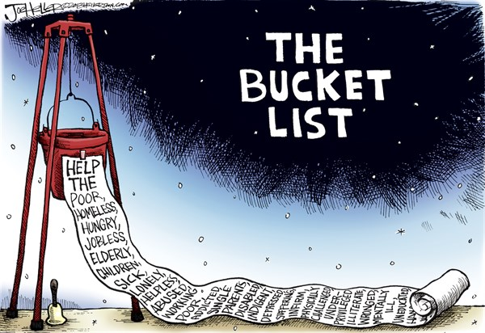
If you haven’t heard about the term “bucket list”, it is a list of all the goals you want to achieve, dreams you want to fulfill and life experiences you desire to experience before you die. Answering the questions below.

- What if you were to die tomorrow? What would you wish you could do before you die?

- What would you do if you had unlimited time, money and resources?

- What have you always wanted to do but have not done yet?

- Any countries, places or locations you want to visit?

- What are your biggest goals and dreams?

- What do you want to see in person?

- What achievements do you want to have?
- What experiences do you want to have / feel?

- Are there any special moments you want to witness?

- What activities or skills do you want to learn or try out?

- What are the most important things you can ever do?

- What would you like to say/do together with other people? People you love? Family? Friends?

- Are there any specific people you want to meet in person?

- What do you want to achieve in the different areas: Social, Love, Family, Career, Finance, Health (Your weight, Fitness level), Spiritual?

- What do you need to do to lead a life of the greatest meaning?

What’s on your bucket list? List your top 10!

